Jinny Huh

PUBLICATIONS
Books
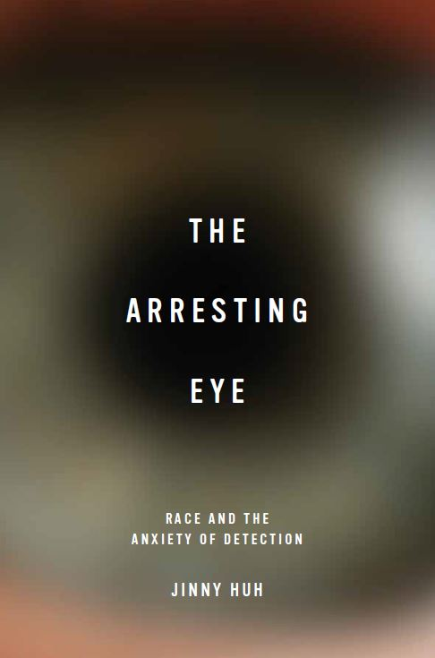 | The Arresting Eye: Race and the Anxiety of Detection. Charlottesville:  University of Virginia Press. May 2015.

Articles, Chapters, and Essays
“Racial Speculations: (Bio)Technology, Battlestar Galactica, and a Mixed-Race Imagining” | Techno-Orientalism in Science Fiction, Film, Media, and Literature. Eds. Betsy Huang, Greta Niu, and David Roh. New Brunswick: Rutgers University Press. April 2015. 101-112.
“Race in Progress, No Passing Zone: Battlestar Galactica, Colorblindness, and  the Maintenance of Racial Order” | The Colorblind Screen: Television and PostRacial America. Eds. Sarah Nilsen and Sarah Turner. New York: NYU Press,  2014. 320-343.
“Detecting Winnifred Eaton” | MELUS. Vol. 39, No. 1 (Spring 2014): 82-105.
“Whispers of Norbury: Sir Arthur Conan Doyle and the Modernist Crisis of  Racial (Un)Detection” | Modern Fiction Studies. Special Issue on “Racechange and the Fictions of Identity.” Vol. 49, No. 3 (Fall 2003): 550-580
“Cathy Song” | Dictionary of Literary Biography. Volume on Asian American Authors. October 2003. 15 pages.

