Lisa Schnell
PUBLICATIONS
Books
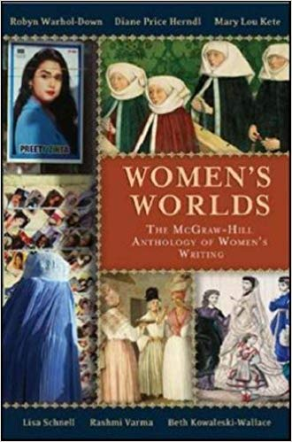 | Women’s Worlds: the McGraw-Hill Anthology of Women’s Writing in English Across the Globe. With Robyn Warhol-Down, Beth Kowaleski-Wallace, Mary Lou Kete, Rashmi Varma, and Diane Price-Herndl. New York: McGraw-Hill, 2007.
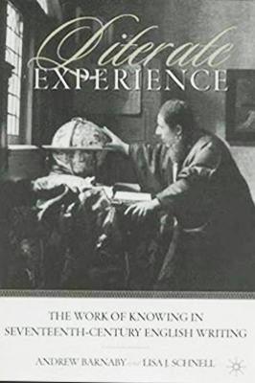 | Literate Experience: The Work of Knowing in Seventeenth-Century English Writing. Co-authored with Andrew Barnaby. New York: Palgrave/St. Martin's, 2002.
Selected Articles
“Aemilia Lanyer” | Encyclopedia of English Renaissance Literature, eds. Garrett Sullivan and Alan Stewart. Oxford: Wiley-Blackwell, 2012.
“Shoresh” | The WRUV Reader, ed. Chris Evans.
“Let me not pyne for poverty: Maternal Elegy in Early Modern England” | Oxford Handbook of the Elegy, ed. Karen Weisman. Oxford, UK: Oxford University Press, 2010.
“Breaking ‘the rule of Cortezia’: Aemilia Lanyer’s Dedications to Salve Deus Rex Judaeorum.” | Reprinted in Ashgate Critical Essays on Women Writers in England, 1550-1700: Volume 3: Anne Lock, Isabella Whitney and Aemilia Lanyer. Edited by Micheline White. Surrey, UK: Ashgate Publishing Ltd., 2009.
“Learning How To Tell.” | Reprinted in Psychoanalysis and Narrative Medicine. Edited by Peter Rudnytsky and Rita Charon. Binghamton, NY: SUNY Press, 2008.

