Jean Bessette

PUBLICATIONS
Books
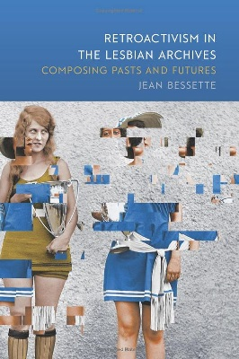 | Retroactivism in the Lesbian Archives: Composing Pasts and Futures. Southern Illinois University Press, Studies in Rhetorics and Feminisms series. December 2017.
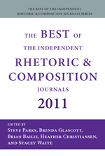 | The Best of Rhetoric and Composition 2011: Essays from the Independent Journals. Associate Editor. Anderson, SC:Parlor Press, 2011.

Articles and Chapters
"'Rightness' in Retrospect: Stonewall and the Sacred Call of Kairos." | Responding to the Sacred: An Inquiry into the Limits of Rhetoric. Edited by Michael Bernard-Donals and Kyle Jensen. Collection under advanced contract at Penn State University Press. 2019.
"Love in a Hall of Mirrors': Queer Historiography and the Unsettling In-Between." | Re/Orienting Writing Studies: Queer Methods, Queer Projects. Utah State University Press. November 2018.
“Queer Rhetoric in Situ.” | Rhetoric Review. Vol. 35. 2. March 2016.
“Audio, Archives, and the Affordance of Listening in a Pedagogy of ‘Difference’.” | Computers and Composition 39. December 2015.
“Past-Writing: Negotiating the Complexity of Memory and Experience.” | Critical Expressivism: Theory and Practice in the Composition Classroom. Eds. Tara Roeder and Roseanne Gatto. Parlor Press, 2015.
“Meaningful Engagements: Feminist Historiography and the Digital Humanities.” | With Jessica Enoch. College Composition and Communication. 64.4. June 2013.
“An Archive of Anecdotes: Raising Lesbian Consciousness after the Daughters of Bilitis.” | Rhetoric Society Quarterly. 43.1. January 2013.

